**Orientation Challenge: Weather Forecast**



*By: Johnson Domacasse (#4471709)*

*11 March 2024*

Contents

1. Introduction: 3

2. Steps taken: 3

3. Bibliography: 4

# Introduction:

This challenge will be a continuation of both the IoT and HMI node red implementations. The focus of this challenge was to collect sensor data which will then be passed to a model which will predict whether the weather index will be good or bad. This report will go over the steps taken, the problems that were encountered and how they were solved.

***Note:***I would like to give thanks to my classmates, Gergana and Benyamin for assistance in solving some of the problems.

# Steps taken:

I took a look at the bottom of the challenge document and noticed that there was a lot of problems that can occur in the making of this assignment. One of which was the node.js being too new. My first step was to uninstall this and reinstall it but with an older version. I also installed docker to run an image containing the node-red that recognizes the machine learning extension**[3]**.

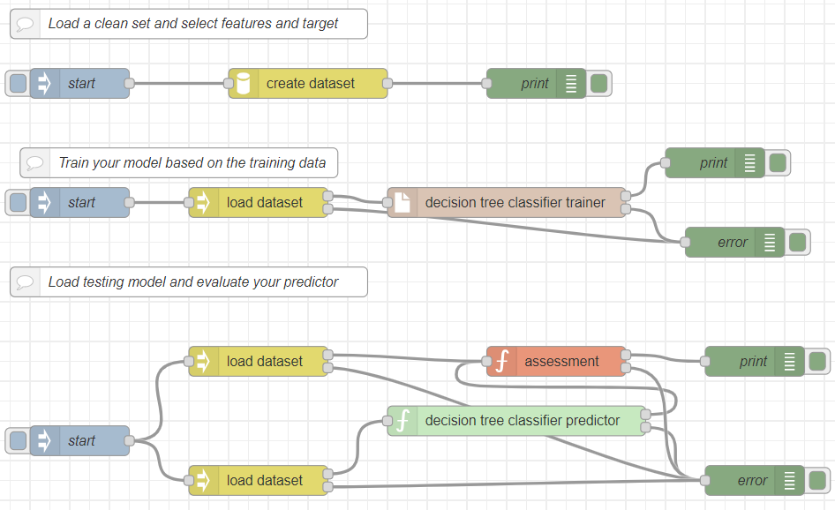After confirming that this works with the Iris data set, I begin working on implementing this into my weather forecast program**[2]**.

From there I rechecked if my old program to collect the sensor information still worked before continuing. After confirming that it is still publishing the correct data to the correct MQTT topic, I added a JSON node to format the data into an object that we can work with. From there in the function block, I check both the humidity and the temperature ranges to see whether the weather is going to be good or bad. Based on this condition, we change the value of the “weather” variable to a 1 or 0**[1]**. We then format this data into a csv file within the docker image (the original one in node-red did not function). I save this data along with the iris.csv file.

Now that I have the correct csv file it was time to make the dataset and from there predict the weather. While creating the dataset, I noticed that some errors come up regarding an index within the create dataset node. This was due to the input and the output being the incorrect values. For example, the input should’ve been “0,1” instead of "0,1,2,3”. The output remained 4. After this, the model finally created the dataset and I was able to train the model and load the testing model and predictor.

Another problem I encountered was within the nodes to create the file, create the dataset and load the dataset, I needed to have the correct paths. At first I was confused where they needed to go. This was solved by reverse engineering the iris example and seeing where everything needed to go and replicating this to the weather model.

# Bibliography:

**[1] -** Wikimedia Foundation. (2024, January 1). *Heat index*. Wikipedia. <https://en.wikipedia.org/wiki/Heat_index>

**[2] -** Lavrenko, V. (2014b, January 19). *Decision tree 1: How it works*. YouTube. <https://www.youtube.com/watch?v=eKD5gxPPeY0&list=PLBv09BD7ez_4temBw7vLA19p3tdQH6FYO&index=2>

**[3] -** *Machine learning with node-red+arduino*. Sriparna’s blog on Internet of Things. (2019, December 20). <https://sriparnaiot.wordpress.com/machine-learning-with-node-redarduino/>